**1 INDRODUTION**

**1.1 Overview**

**Designing Professional Business Cards**

**In this project we create business cards in canva app. In this project**

**1.2 Purpose**

**We created it for the students to learn PHONETICS on the go**

**2 Problem Definition &Design Thinking**

**2.1 Empathy Map**

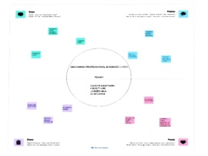

**2.2 ideation &Brainstorming map**

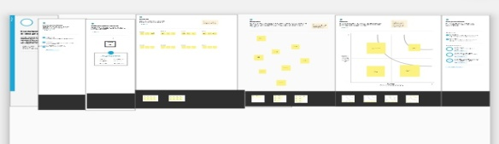

**3 result**

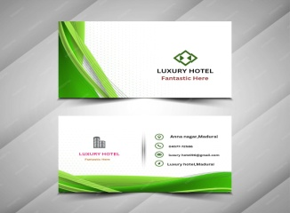

**4 ADVANTAGES&DISADVANTAGES**

**It is useful for all the nan_native English speakers to learn the proper**

**Pronounciation on the go.**

**It ‘s disadvantage is ,it doesn’t have the practical session .**

**5 APPLICATION**

**It is so much useful for the students and non native English to learn proper pronounciation.**

**6.CONCLUSION**

**We learn a lot of new things about editing and make it useful for others .**